Real World Cybersecurity Attacks

WhatsApp Spyware Hack (2024)
Pegasus is a spyware that was established by NSO group (Israeli Cyber Arms Company). It is generally capable of reading text messages, accessing to the camera and microphone, snooping calls, collecting the passwords and more. It was initially suspected when there was a failed attempt to access a human right’s activist mobile.

NSO group had stated that its main goal is to be used against serious crime and terrorism. But there’s a belief that the tech has been used for national security threat as well.
(Anon., 2025)
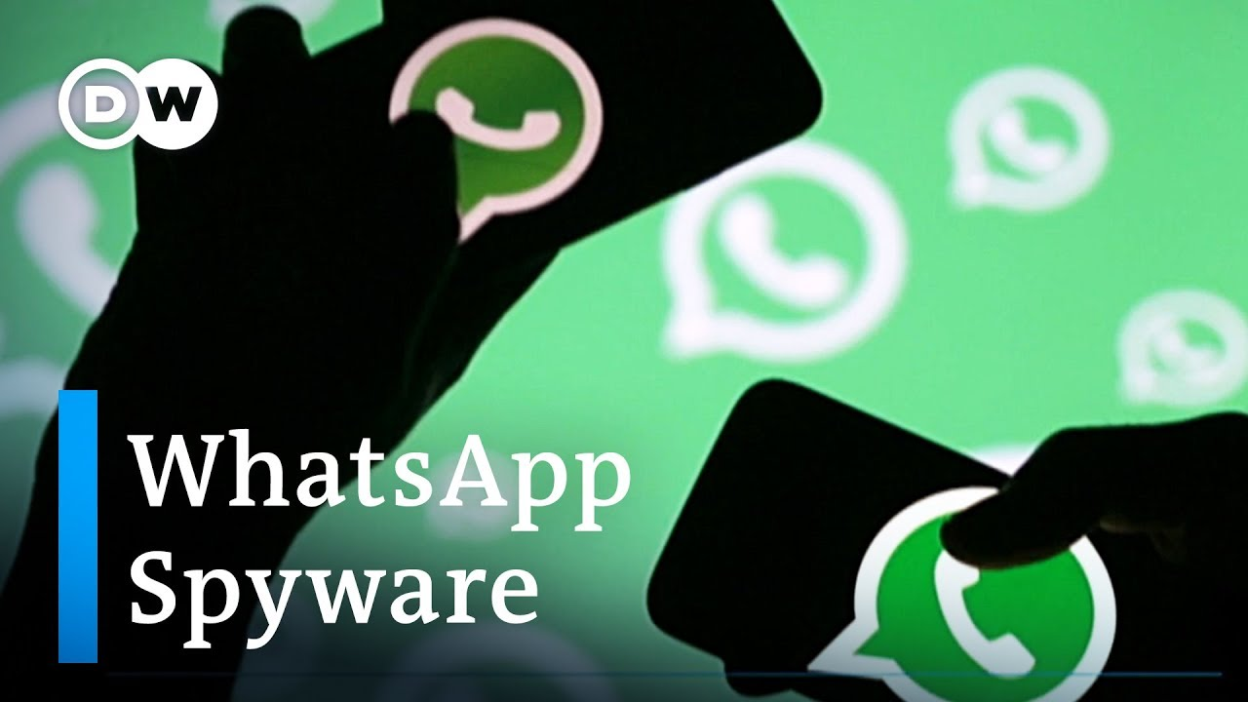
Figure 1: Pegasus

This case was resolved when combination of technical patches was made in use. The parent company, Meta, had made use development tools for detecting the spyware.
The WhatsApp security team quickly released a software update to deal with the ongoing issue. It seemed like the main fault was in the operating systems of mobile phones so Apple and Android continuously released update to avoid this kind of attack in future.

LinkedIn Data Breach Incident
About 164 million email addresses and passwords were exposed in LinkedIn data breach in 2016. The data was sold to a dark market site 4 years ago by the hackers.
(Anon., 2025)
Security Measures to be Taken:
- Enabling two – factor authentication
- Password Manager
- Using strong password
- Changing Passwords
- Detect malware and protect the system
- Education and awareness related to cyber attacks
This not only harmed LinkedIn legally, it also marked a very bad reputation in market. Scraping is a tool that is used to access the information from websites.
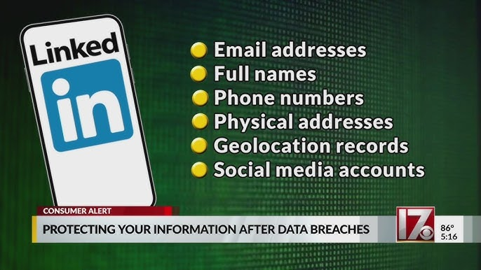
Figure 2: LinkedIn Data Breach

